**DAILY ONLINE ACTIVITIES SUMMARY**

|  |  |  |  |  |  |  |  |  |
| --- | --- | --- | --- | --- | --- | --- | --- | --- |
| **Date:** | **09-06-2020** | | | | | **Name:** | **ROUSHA** | |
| **Sem & Sec** | **6 B** | | | | | **USN:** | **4AL17CS079** | |
| **Online Test Summary** | | | | | | | | |
| **Subject** | | **1)COMPUTER GRAPHICS AND VISUALIZATION**  **2)CRYPTOGRAPHY, NETWORK SECURITY AND CYBER LAWS** | | | | | | |
| **Max. Marks** | | **1)30**  **2)60** | | **Score** | | | **1)27**  **2)37** | |
| **Certification Course Summary** | | | | | | | | |
| **Course** | **Learn C++ From Scratch - A Hands On Course** | | | | | | | |
| **Certificate Provider** | | | **Udemy** | | **Duration** | | | **1 day** |
| **Coding Challenges** | | | | | | | | |
| **Problem Statement: 2 Python and 1 Java Programs** | | | | | | | | |
| **Status: Executed** | | | | | | | | |
| **Uploaded the report in Github** | | | | | **Yes** | | | |
| **If yes Repository name** | | | | | https://github.com/rousharousha/DailyReport.git | | | |
| **Uploaded the report in slack** | | | | | **Yes** | | | |

Online Test Details: (Attach the snapshot and briefly write the report for the same)

**COMPUTER GRAPHICS AND VISUALIZATION:**

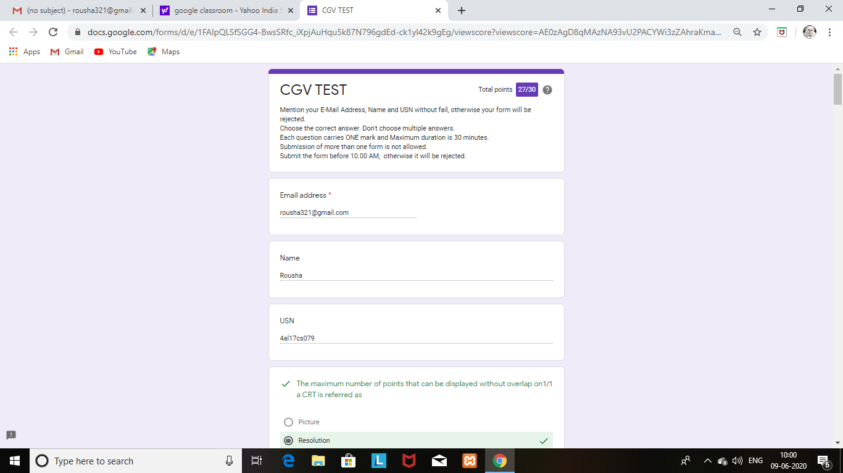

**CRYPTOGRAPHY, NETWORK SECURITY AND CYBER LAWS:**

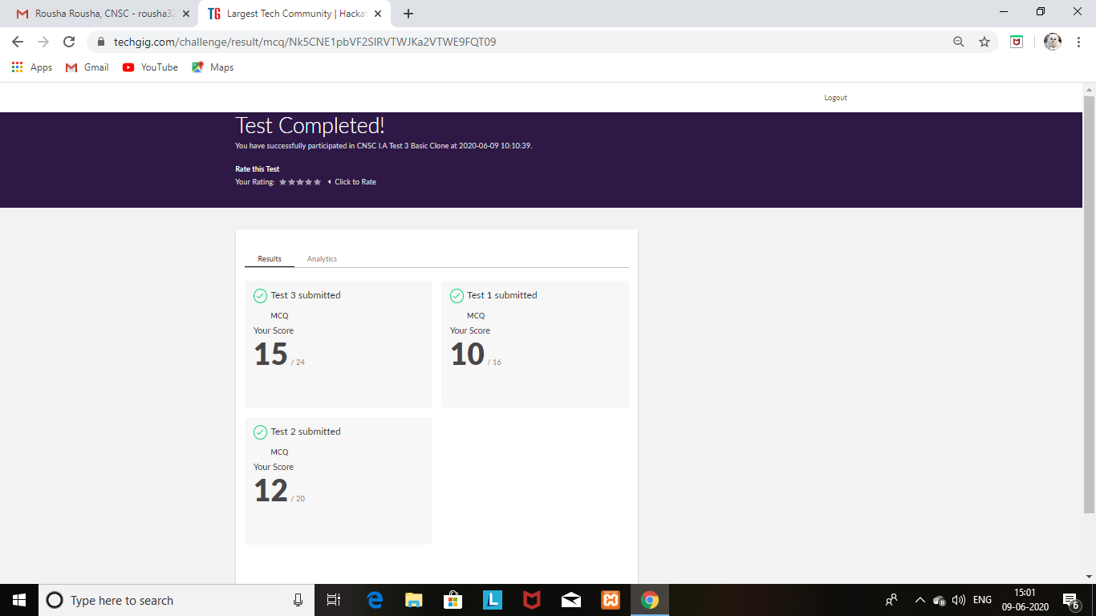

Certification Course Details: (Attach the snapshot and briefly write the report for the same)

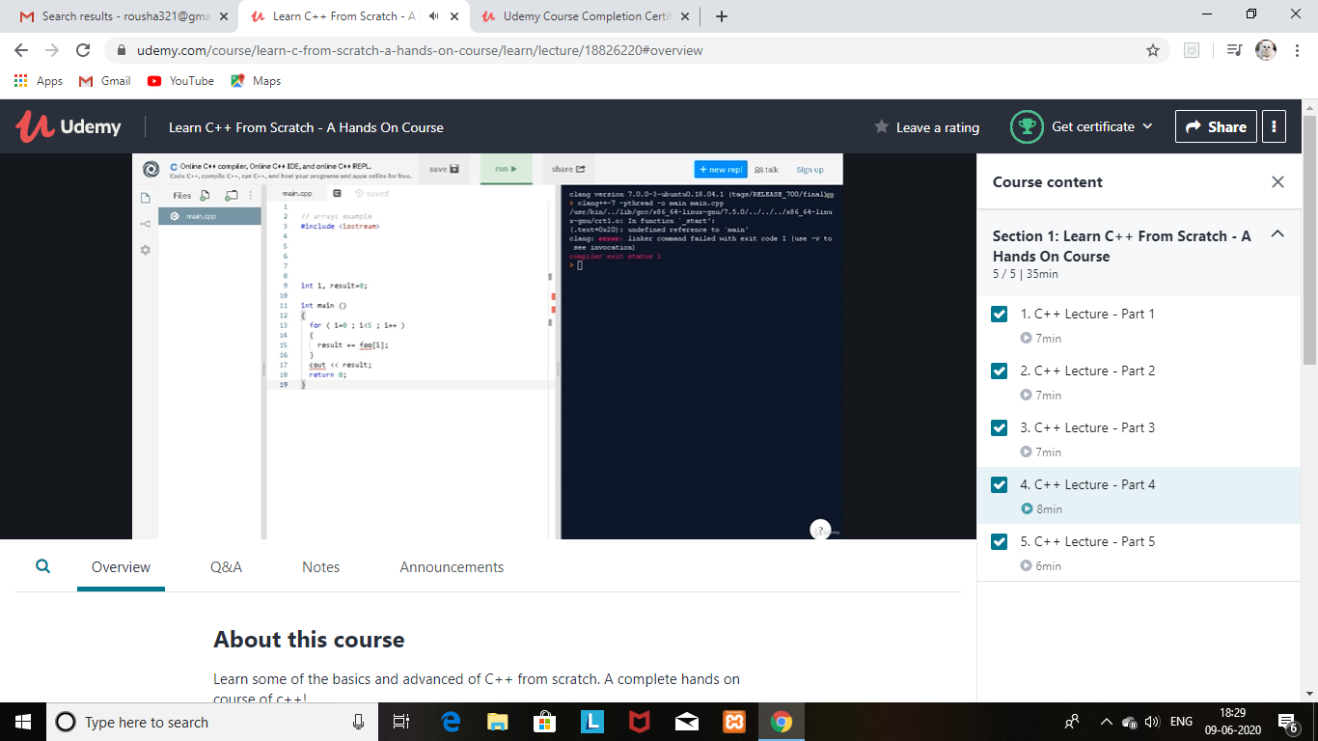

Completed the course and obtained a certificate for the same and uploaded it in Github repository.

Certificate:

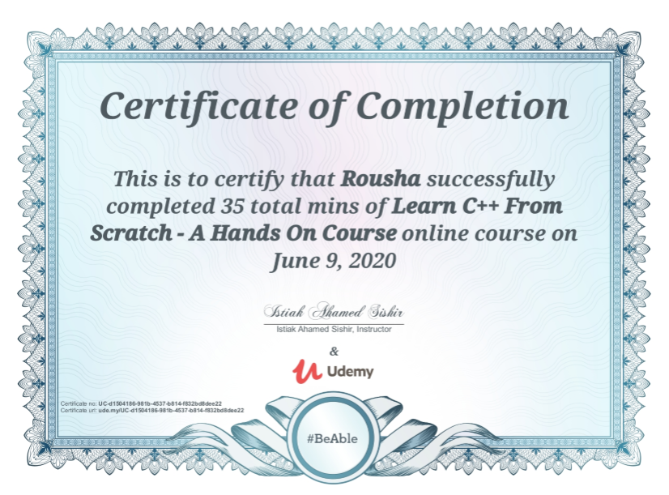

Coding Challenges Details: (Attach the snapshot and briefly write the report for the same)

Program1:

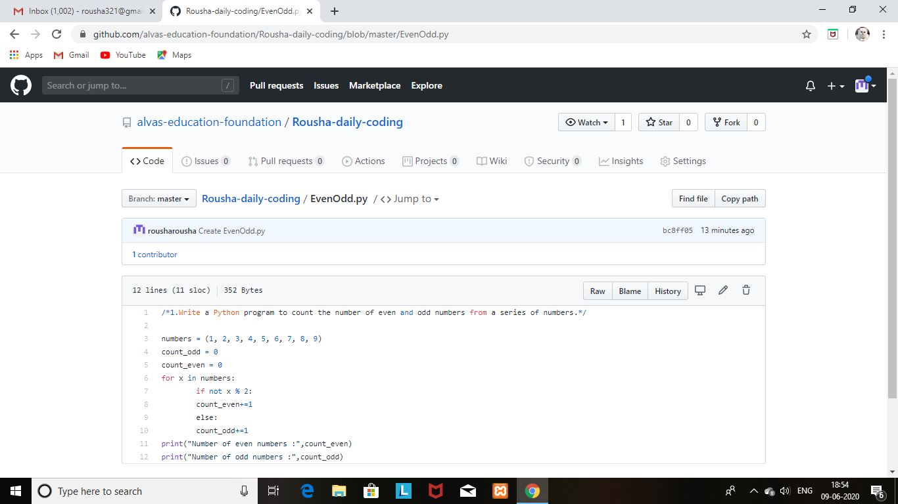

Program2:

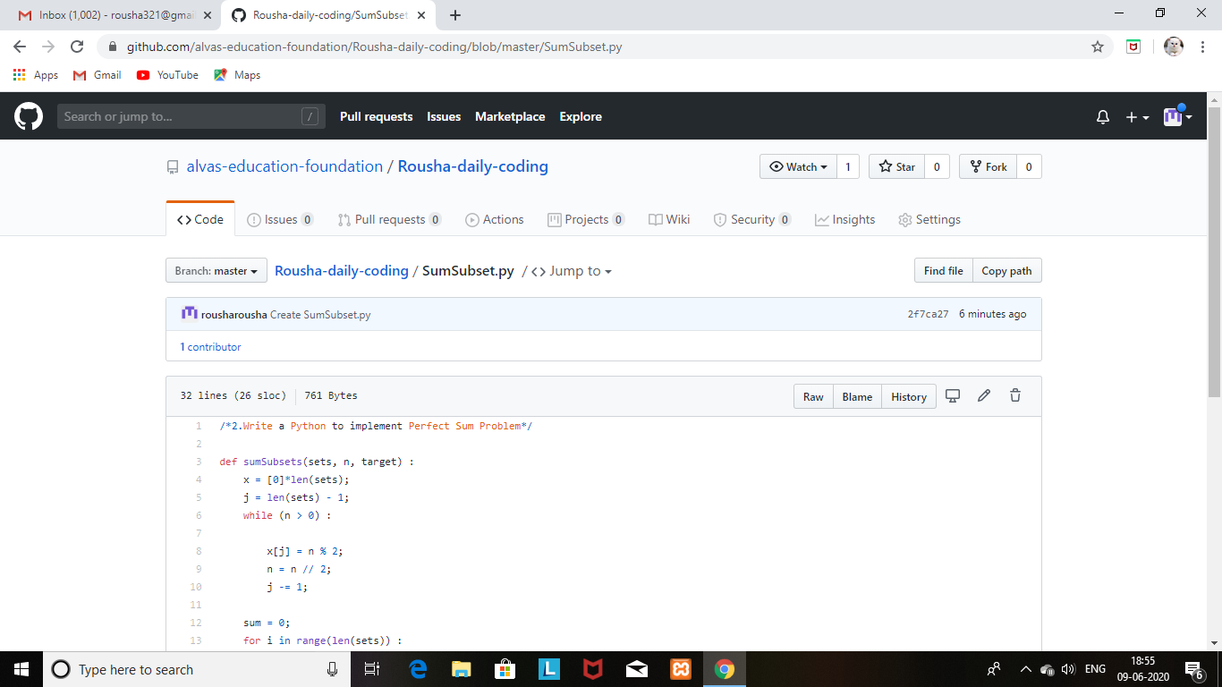

Program3:

